Design Specification – Transaction Screen

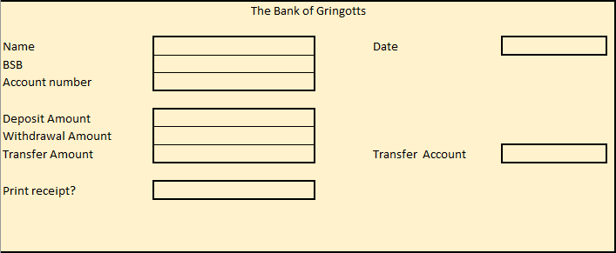

|  |  |
| --- | --- |
| Field | Description |
| Name | The name of customer. The field accepts only alpha characters. The total number of characters cannot exceed 40 |
| Date | Accepts dates as dd/mm/yy. Dates cannot be less than 2 days prior to current date or 5 days greater than current date. The -2/+5 rule counts business days only. |
| BSB | Bank State Branch value. Must be in the format XXX-XXX |
| Account number | The account number in which the transaction will take place. Account numbers cannot be less than 5 digits or more than 10 digits. The lowest account number is 00001 the highest account number 9999999999. Some accounts contain a starting or ending capitalised letter. |
| Deposit amount | The amount to be deposited into the account. Maximum deposit is 10,000.00. Negatives are not accepted. Separating commas are inserted by the field logic. Numeric values are valid, all other are invalid. |
| Withdrawal amount | Refer Deposit amount field |
| Transfer amount | Refer Deposit amount field |
| Transfer account | The account into which funds will be transferred. Is only active if a value entered into Transfer amount field. Cannot be the same as the value in Account number field. This field must contain the BSB value as well as the account number. |
| Print receipt | If customer wants receipt, “Y”. If left blank or “N” no receipts printed. If “S” followed by 1 to 12 a statement is printed. |